**Innovation:**

Blood group detection is an important task in the field of medical science. It helps in determining the type of blood a person has, which is essential for carrying out blood transfusions and organ transplants. In recent years, computer vision has become a powerful tool for analyzing medical images. In this report, we will discuss the development of a blood group detection application using OpenCV in Python.

On day to day scale of things blood group detection may not be that important of a task but it is highly important in the field of medicine. Especially before operations of high magnitude like organ transplants and blood transfusion. This may sometimes be an emergency. But our traditional methods of finding blood group in labs take a long time and is a tedious process. It also has a chance of negligent human errors .To overcome this we have devised software to process the image of blood samples which has different reagents and determine the blood time in minimum possible time.

**Methodology:**

The blood group detection application is developed using the following steps:

* **Step 1:** Image Acquisition

The first step in the development of the application is to acquire an image of the blood sample. The image can be captured using a digital camera or a scanner.

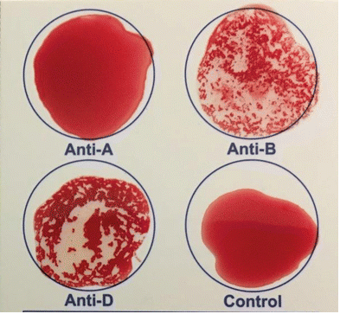Sample images:

* **Step 2:** Image Preprocessing

Once the image is acquired, it is preprocessed to remove any noise and enhance the contrast. This is done using OpenCV functions like thresholding, morphological operations, and image smoothing.

Sample Results:

* **Step 3:** Region of Interest Extraction

The next step is to extract the region of interest (ROI) from the preprocessed image. This is done by identifying the circular shape of the blood group and using it to define the ROI.

* **Step 4:** Blood Group Detection

After extracting the ROI, the blood group is detected using image segmentation techniques. The segmented image is then classified using machine learning algorithms like support vector machines (SVM) or convolutional neural networks (CNN).

* **Step 5:** Result Display

The final step is to display the results of the blood group detection. This can be done by displaying the detected blood group on the original image or by displaying it as text.

**Objectives of the project:**

* Reduce time to determine blood type.
* Eliminate human error as much as possible.
* Open possibilities for further development by giving entire analysis of bool sample

**Scope of the project:**

* A software the is easily manageable by user and determines blood group by applying image processing technique on the uploaded image.

**System Design:**

**Block Diagram:**

**Implementation:**

The software that is built is installed in a computer with computational power as to handle pythons powerful libraries and other programs. Once the image is uploaded by the user, the software determines the blood group.

**Summary:**

This is aimed at delivering just the blood group with maximum possible accuracy. There is a lot of scope for improvement and a expandable base for entire analysis of blood sample using image processing. We hope this would greatly benefit the field of medicine.